LECTURE 4
NETWORK SECURITY

1) Security
1.1 Meaning of Security
Security refers to the protection of information, systems, and resources from unauthorized access, misuse, modification, destruction, or disruption.
In the context of computer systems and blockchain technology, security ensures that digital information remains protected against internal and external threats.
Security is mainly concerned with protecting data and ensuring trust in systems.
1.2 Objectives of Security (CIA Triad)
Security is based on three fundamental principles known as the CIA Triad:
- Confidentiality
- Integrity
- Availability
These three together form the foundation of information security.
1.2.1 Confidentiality
Definition
Confidentiality ensures that information is accessible only to authorized users and is not disclosed to unauthorized individuals.
Why It Is Important
If confidential information is exposed:
- Financial loss may occur
- Privacy may be violated
- Organizational reputation may be damaged
How It Is Achieved
- Encryption
- Password protection
- Access control mechanisms
- Authentication systems
Example
When you log into online banking:
- Only you (authorized user) should see your account details.
- If a hacker reads your account balance, confidentiality is violated.
1.2.2 Integrity
Definition
Integrity ensures that information remains accurate, complete, and unaltered during storage or transmission.
Why It Is Important
If data is modified without permission:
- Decisions based on data become incorrect
- Systems become unreliable
How It Is Achieved
- Hash functions
- Digital signatures
- Message authentication codes
Example
If someone changes a transaction amount from 1,000 to 10,000 during transfer, integrity is compromised.
1.2.3 Availability
Definition
Availability ensures that information and systems are accessible when required by authorized users.
Why It Is Important
Even if data is confidential and accurate, it is useless if users cannot access it when needed.
How It Is Achieved
- Backup systems
- Redundant servers
- Protection against DoS attacks
Example
If a website crashes due to a Denial of Service attack, availability is compromised.

2) Network Security
2.1 Definition
Network Security refers to the measures taken to protect data during transmission over communication networks.
When data travels from sender to receiver, it passes through multiple intermediate devices such as routers, switches, and servers. During this journey, it is vulnerable to attacks.
2.2 Why Network Security Is Needed
During transmission, data may be:
- Intercepted (read by unauthorized person)
- Modified (changed during transit)
- Destroyed (lost or corrupted)
- Blocked (denied access)
Network security ensures:
- Confidential communication
- Safe data transfer
- Protection against attackers
2.3 Example of Network Communication
Sender (S) → Network → Receiver (R)
Without security:
- An attacker can use packet sniffers to capture data.
- Sensitive information like passwords can be stolen.
With network security:
- Data is encrypted.
- Even if intercepted, it cannot be understood.

3) Aspects of Security
Security consists of three important components:
- Security Attack
- Security Mechanism
- Security Service
These three work together in a protection system.
3.1 Security Attack
Definition
A security attack is any action that compromises the confidentiality, integrity, or availability of information.
Example
- Hacking into a system
- Altering database records
- Crashing a server
An attack is an active attempt to break security.
3.2 Security Mechanism
Definition
A security mechanism is a method or technique designed to detect, prevent, or recover from security attacks.
Purpose
To provide protection against threats.
Examples
- Encryption algorithms
- Firewalls
- Intrusion Detection Systems (IDS)
- Antivirus software
Mechanisms are tools used to enforce security.
3.3 Security Service
Definition
A security service enhances the security of data processing systems and information transfer.
It is designed specifically to counter security attacks.
Examples
- Authentication service
- Data confidentiality service
- Access control service
Services provide overall protection functions using security mechanisms.

4) Threat & Attack
4.1 Threat
Definition
A threat is a potential danger that can harm an asset by affecting its confidentiality, integrity, availability, or legitimate use.
A threat represents the possibility of an attack.
Examples
- A hacker planning to break into a system
- Malware existing on the internet
- Natural disasters affecting servers
Threat = Potential risk.
4.2 Types of Threats
4.2.1 Passive Threat
- Monitoring communication
- No modification of data
- Goal is to gather information
Example:
Eavesdropping on emails.
Passive threats are difficult to detect because no data is altered.
4.2.2 Active Threat
- Deliberate alteration of information
- Involves disruption or modification
Example:
Changing a transaction message before it reaches the receiver.
Active threats are easier to detect because they disturb normal operation.
4.3 Attack
Definition
An attack is the realization (actual execution) of a threat.
It is an attempt to compromise security.
Threat = Potential danger
Attack = Actual harmful action
4.4 Categories of Attacks
Security attacks are classified into four main categories:
4.4.1 Interruption
The system or data becomes unavailable.
Examples:
- Cutting fiber cable
- Crashing a server
- Denial of Service (DoS) attack
Affects: Availability
4.4.2 Interception
Unauthorized access to data.
Examples:
- Packet sniffing
- Wire tapping
- Illegal copying of files
Affects: Confidentiality
4.4.3 Modification
Unauthorized alteration of data.
Examples:
- Changing message content
- Delaying and modifying a message
Affects: Integrity
4.4.4 Fabrication
Insertion of fake objects or messages into the system.
Examples:
- Impersonation (Masquerading)
- Sending fake emails
Affects: Authenticity and Integrity
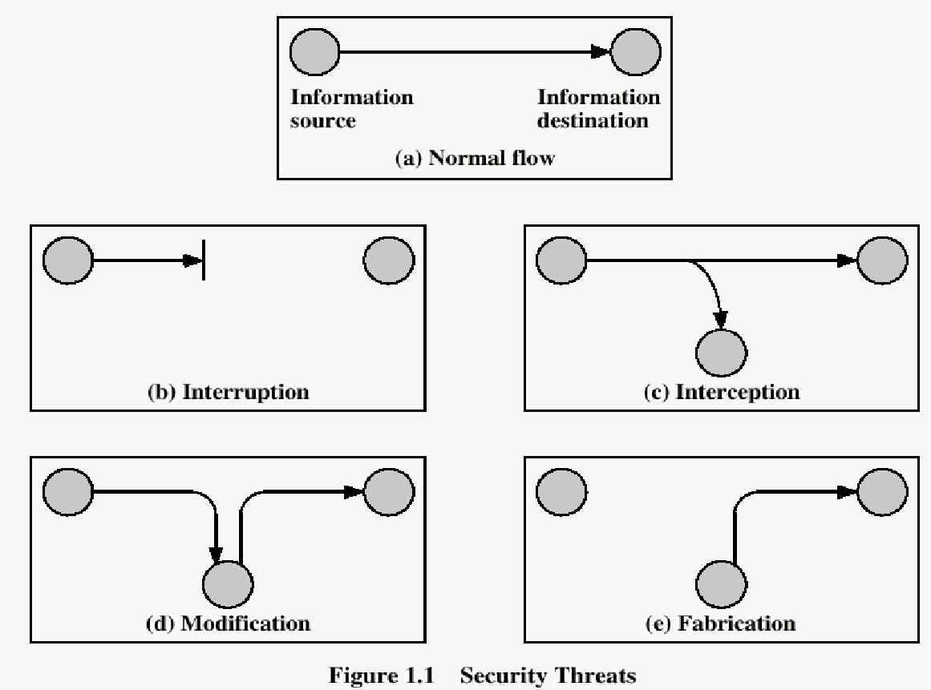

5) Interruption
5.1 Definition
Interruption is a type of security attack in which system resources, data, or services become unavailable or unusable.
It primarily affects the Availability of the system.
S
R
5.2 How It Happens
An attacker may:
- Destroy hardware (e.g., cutting fiber cable)
- Corrupt software
- Crash servers
- Overwhelm system resources
5.3 Example
- Denial of Service (DoS) attack
- Physically damaging network cables
- Crashing a server intentionally
If users cannot access a website because it is overloaded, interruption has occurred.

6) Interception
6.1 Definition
Interception is a security attack where unauthorized individuals gain access to information.
It affects the Confidentiality of data.
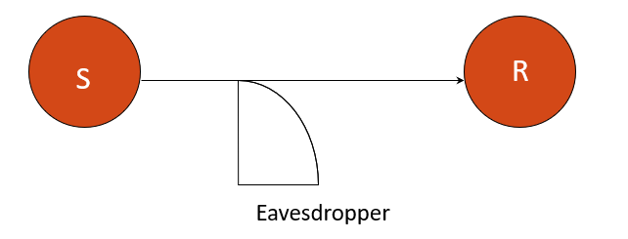
6.2 How It Happens
An attacker may:
- Use packet sniffers
- Perform wire tapping
- Illegally copy files
- Monitor communication channels
The data is not altered, only observed.
6.3 Example
- Reading someone’s email without permission
- Capturing login credentials during transmission

7) Modification
7.1 Definition
Modification is a type of attack where data is altered or changed without authorization.
It affects the Integrity of the system.
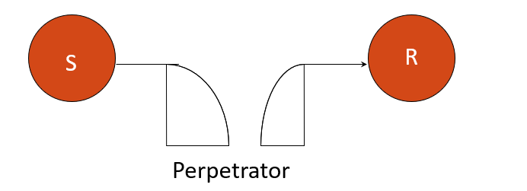
7.2 How It Happens
An attacker may:
- Stop the flow of a message
- Delay the message
- Change message content
- Release the altered message
7.3 Example
Original message: Transfer 1,000
Modified message: Transfer 10,000
Here, integrity is compromised.

8) Fabrication
8.1 Definition
Fabrication is an attack in which an attacker inserts fake data, objects, or messages into the system.
It affects Authenticity and sometimes Integrity.
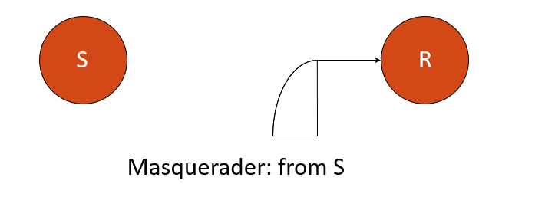
8.2 How It Happens
An attacker may:
- Impersonate another user (Masquerading)
- Generate fake transactions
- Create false messages
8.3 Example
- Sending fake emails pretending to be a bank
- Creating a fake identity to access a system
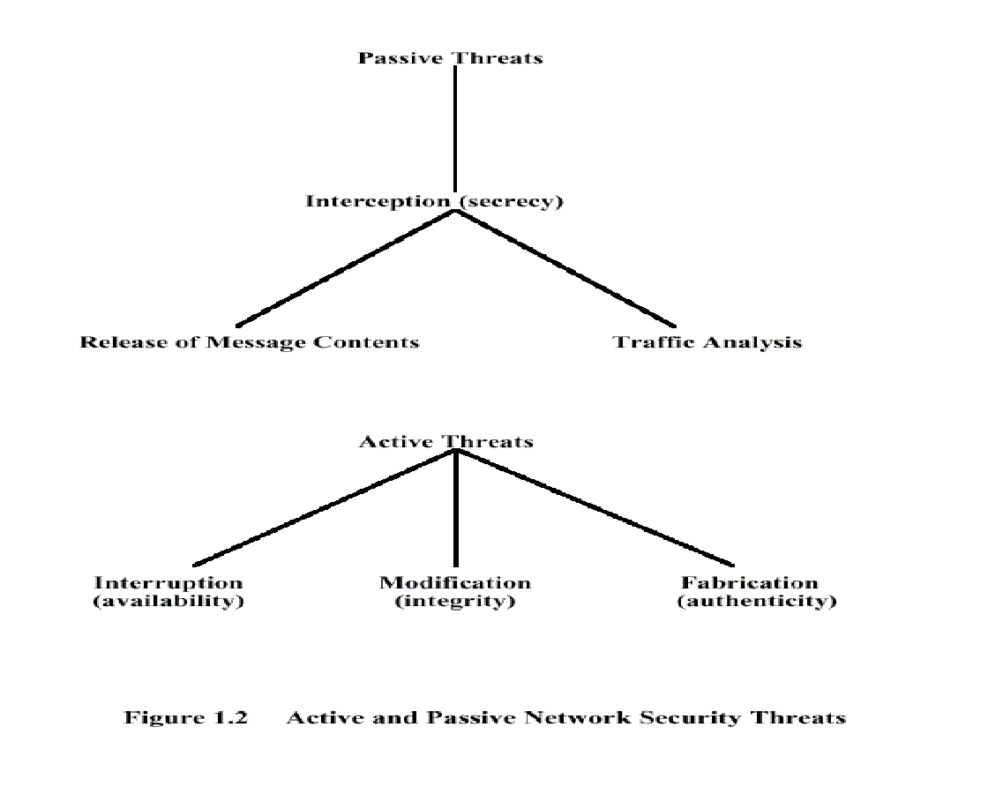
9) Passive Attacks
9.1 Definition
A passive attack involves monitoring or eavesdropping on communication without altering the data.
The goal is to obtain transmitted information.
Passive attacks are difficult to detect because no data is modified.
9.2 Characteristics
- No change in data
- No system disruption
- Hard to detect
- Focused on gathering information
9.3 Example
- Listening to a phone call
- Monitoring email traffic

10) Passive Attack Types
There are two main types of passive attacks:
10.1 Release of Contents
Definition
In this type, the attacker directly obtains the contents of communication.
Example
- Reading an email message
- Listening to a private conversation
- Accessing confidential files
Here, the actual data content is exposed.
10.2 Traffic Analysis
Definition
In traffic analysis, the attacker does not read the actual message content but studies communication patterns.
The attacker analyzes:
- Who is communicating
- Frequency of communication
- Length of messages
- Timing of messages

11) Active Attacks
11.1 Definition
An active attack is a type of security attack in which the attacker modifies the data stream or creates a false data stream.
Unlike passive attacks, active attacks involve alteration, disruption, or destruction of information.
11.2 Characteristics
- Data is modified or fabricated
- System operation is affected
- Easier to detect than passive attacks
- Directly compromises security
11.3 Types of Active Attacks
Active attacks generally include:
- Interruption
- Modification
- Fabrication
11.4 Examples
- Changing transaction data
- Sending fake messages
- Crashing a server
- Impersonating another user
11.5 Security Properties Affected
Active attacks mainly affect:
- Integrity
- Availability
- Authenticity
11.6 Passive vs Active Attack (Important Comparison)
Feature | Passive Attack | Active Attack
Data Altered | No | Yes
Detectability | Difficult | Easier
Example | Eavesdropping | Message modification
Affects | Confidentiality | Integrity, Availability

12) Encryption
12.1 Definition
Encryption is the process of converting readable information (plaintext) into an unreadable form (ciphertext) using algorithms and keys.
Its main goal is to protect information from unauthorized access.
12.2 Why Encryption Is Needed
During storage or transmission, data may be intercepted.
If the data is encrypted, even if an attacker accesses it, they cannot understand it.
Encryption ensures:
- Confidentiality
- Secure communication
- Data protection
12.3 Basic Working of Encryption
Plaintext → Encryption Algorithm + Key → Ciphertext
Ciphertext → Decryption Algorithm + Key → Plaintext
Without the correct key, the original message cannot be recovered.
12.4 Example
Plaintext: HELLO
Encrypted form: KHOOR (after applying shift method)
Only someone with the correct key can decrypt it back to HELLO.

13) Encryption Types
Encryption techniques are mainly divided into:
- Steganography
- Cryptography
Both are used to conceal information, but they work differently.
13.1 Steganography
13.1.1 Definition
Steganography means “covered writing.”
It is the science of hiding secret information within some other less important information so that the existence of the message is hidden.
Unlike cryptography, steganography hides the presence of the message itself.
13.1.2 How It Works
Secret data is hidden inside:
- Images
- Audio files
- Video files
- Text files
One common method is the Least Significant Bit (LSB) method.
13.1.3 LSB Method (Concept)
A digital image consists of pixels.
Each pixel has RGB values.
Example pixel:
Red = 10110110
Green = 11001001
Blue = 10011100
By changing the last bit of these values slightly, secret binary data can be hidden without visibly changing the image.
The image looks normal, but it contains hidden data.
13.1.4 Examples
- Invisible ink
- Secret messages inside images
- File hidden inside another file
13.1.5 Drawback
If the cover file is detected or modified, the hidden information may be extracted or destroyed.
13.2 Cryptography
13.2.1 Definition
Cryptography means “hidden writing.”
It is the technique of securing information by converting it into an unintelligible form using codes and secret keys.
Even if an attacker accesses the data, they cannot understand it without the key.
13.2.2 Purpose
- Protect sensitive information
- Secure communication
- Prevent unauthorized access
13.2.3 Basic Working
Plaintext + Key → Ciphertext
Ciphertext + Key → Plaintext
The security depends on the secrecy of the key.

14) Encryption Types: Steganography
1) Meaning of Steganography
Steganography is the technique of hiding secret information inside another normal file (image, audio, video, text) in such a way that no one suspects that a secret message exists.
Unlike cryptography, which hides the meaning of the message,
Steganography hides the existence of the message.
2) How It Works – Least Significant Bit (LSB) Method
2.1 Basic Idea of LSB
A digital image is made up of pixels.
Each pixel contains 3 color values:
- Red (R)
- Green (G)
- Blue (B)
Each color value is stored in 8 bits (1 byte).
Example of one pixel:
Red = 10110110
Green = 11001001
Blue = 10011100
Now observe something important:
The last bit (rightmost bit) in each value is called the
Least Significant Bit (LSB)
Why?
Because changing this last bit causes very tiny color change
that human eyes cannot detect.
That is the key idea behind LSB steganography.
2.2 Why LSB Works
In an 8-bit value:
Example:
Red = 10110110 (decimal 182)
If we change only the last bit:
10110111 (decimal 183)
The color difference between 182 and 183 is so small that
the image looks exactly the same.
So we use this last bit to hide secret data.
3) Step-by-Step Working of LSB Method
Now let’s understand with a full working example.
Step 1: Convert Secret Message into Binary
Suppose we want to hide the letter: H
ASCII value of H = 72
Binary of 72 = 01001000
So the secret data we want to hide is:
0 1 0 0 1 0 0 0
We need 8 bits to store this.
Step 2: Take Pixels from Image
Suppose we take 3 pixels:
Pixel 1:
R = 10110110
G = 11001001
B = 10011100
Pixel 2:
R = 10101010
G = 01100101
B = 11001100
Pixel 3:
R = 11100011
G = 01010101
B = 10011010
Each color has 1 LSB →
Total available LSBs = 9 bits (3 pixels × 3 colors)
We only need 8 bits for letter H.
Step 3: Replace LSB with Secret Bits
Now we replace the last bit of each color with message bits.
Message bits:
0 1 0 0 1 0 0 0
Now modify:
Pixel 1:
R = 10110110 → replace with 0 (same)
G = 11001001 → replace with 1 (same)
B = 10011100 → replace with 0 (same)
Pixel 2:
R = 10101010 → replace with 0 (same)
G = 01100101 → replace with 1 (same)
B = 11001100 → replace with 0 (same)
Pixel 3:
R = 11100011 → replace with 0 → becomes 11100010
G = 01010101 → replace with 0 → becomes 01010100
Now all 8 bits are embedded.
Notice:
Most bits did not even change.
Only very few changed slightly.
4) What Happens After Embedding?
The image:
✔ Looks exactly the same
✔ Shows no visible difference
✔ But now secretly contains binary data
To extract the message:
Receiver simply:
- Reads the LSB of each color
- Collects the bits
- Converts binary back to ASCII
- Gets the original message
5) Why Human Eye Cannot Detect It
Because:
Original Red value: 182
Modified Red value: 183
Difference = 1
Human eyes cannot detect such tiny pixel differences.
That’s why LSB method is effective.
6) Complete Flow of LSB Steganography
Secret Message
↓
Convert to Binary
↓
Select Image Pixels
↓
Replace LSBs with Secret Bits
↓
Save New Image (Stego Image)
Receiver:
Extract LSBs → Convert to Text → Original Message
7) Advantages of LSB Method
Simple to implement
Very low visual distortion
Large image can hide large data
8) Limitations / Weakness
If image is compressed (like JPEG compression), data may be lost
If attacker suspects steganography, tools can detect patterns
If image is modified (cropped/resized), hidden data may be destroyed

15) Encryption Types: Cryptography
1) Cryptography
The word cryptography comes from:
- Crypt → hidden
- Graphy → writing
Cryptography is the technique of securing information and communication by converting readable data (plaintext) into an unreadable form (ciphertext) using mathematical algorithms and keys.
It ensures that only the intended receiver can understand the information.
1.1 Purpose of Cryptography
Cryptography is used to:
- Protect confidential information
- Secure online transactions
- Prevent unauthorized access
- Maintain data integrity
- Provide authentication
1.2 Basic Working of Cryptography
Plaintext + Algorithm + Key → Ciphertext
Ciphertext + Algorithm + Key → Plaintext
Without the correct key, the attacker cannot recover the original message.
1.3 Example (Conceptual)
Plaintext: HELLO
Key: 3
Encryption rule: Shift each letter forward by 3
H → K
E → H
L → O
L → O
O → R
Ciphertext = KHOOR
Using the same key, decryption gives back HELLO.

16) Types of Cryptography
Cryptography is mainly divided into two types:
- Symmetric Key Cryptography
- Asymmetric Key Cryptography
The main difference lies in how keys are used for encryption and decryption.
16.1 Symmetric Key Cryptography
16.1.1 Definition
Symmetric Key Cryptography is a cryptographic technique in which the same secret key is used for both:
- Encryption
- Decryption
The sender and receiver must share the same key securely before communication begins.
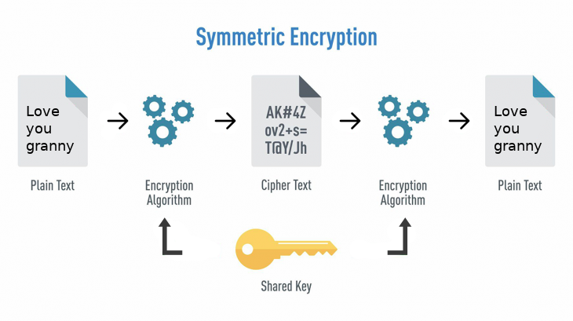
16.1.2 Working of Symmetric Key
Step 1:
Sender encrypts plaintext using a secret key.
Step 2:
Ciphertext is sent over the network.
Step 3:
Receiver uses the same secret key to decrypt the ciphertext.
Diagram Concept
Sender → [Encrypt using Key K] → Ciphertext →
Receiver → [Decrypt using Key K] → Plaintext
Same key (K) is used on both sides.
16.1.3 Example (Simple Concept)
Plaintext: HELLO
Secret Key: 3 (Shift method)
Encryption → KHOOR
Decryption → HELLO
Same key is used in both steps.
16.1.4 Modern Symmetric Algorithms
- AES (Advanced Encryption Standard) – Most secure and widely used
- DES (Data Encryption Standard) – Older, less secure
- 3DES (Triple DES) – Improved version of DES
AES is used in:
- Banking systems
- Wi-Fi security
- VPN
- File encryption
16.1.5 Advantages
Very fast
Efficient for large data
Less computational power required
16.1.6 Disadvantages
Key distribution problem (How to securely share the secret key?)
If key is leaked, entire communication is compromised

16.2 Asymmetric Key Cryptography
16.2.1 Definition
Asymmetric Key Cryptography uses two different keys:
- Public Key (used for encryption)
- Private Key (used for decryption)
The two keys are mathematically related but not identical.
16.2.2 Key Concept
- Public key can be shared with everyone.
- Private key must be kept secret.
- Even if public key is known, data cannot be decrypted without the private key.
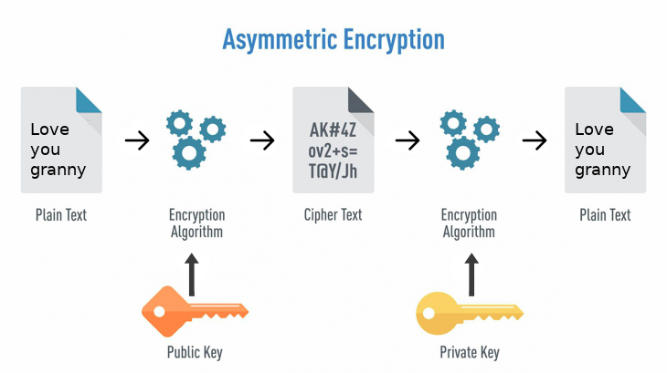
16.2.3 Working of Asymmetric Key
Step 1:
Sender encrypts message using receiver’s public key.
Step 2:
Ciphertext is sent over network.
Step 3:
Receiver decrypts it using their private key.
Diagram Concept
Sender → [Encrypt using Receiver’s Public Key] → Ciphertext →
Receiver → [Decrypt using Private Key] → Plaintext
Different keys are used.
16.2.4 Example (Conceptual Understanding)
Suppose:
Public Key = Lock
Private Key = Unique Key to open lock
Anyone can lock a box using your lock (public key),
but only you can open it using your private key.
16.2.5 Advantages
No need to share secret key
More secure for key exchange
Used in digital signatures
16.2.6 Disadvantages
Slower than symmetric encryption
Requires larger key size
More computational power needed

